**Week 4**

**Aim:** Plotting pdf and CDF continuous R.V

**Code:**

x=seq(0,3-0.01,0.01)

fl=(x^2)/9

plot(x,fl,type="l",xlab="Y",ylab="PDF",xlim=c(0,10))

par(new=TRUE)

x1=seq(3,10,0.01)

f2=0.00000000*x1;

plot(x1,f2,type="l",xlab="Y",ylab="PDF",xlim=c(0,10))

Output:

> x=seq(0,3-0.01,0.01)

> fl=(x^2)/9

> plot(x,fl,type="l",xlab="Y",ylab="PDF",xlim=c(0,10))

> par(new=TRUE)

> x1=seq(3,10,0.01)

> f2=0.00000000*x1;

> plot(x1,f2,type="l",xlab="Y",ylab="PDF",xlim=c(0,10))

Graph:

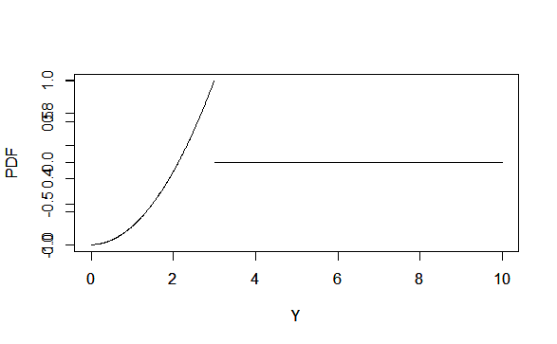

Code 2:

x=seq(0,3-0.01,0.01)

yo=seq(-0.50,3.50,0.01)

y=seq(0,3,0.01)

cdf=c(rep(0,50),y^3/27,rep(1,50))

plot(yo,cdf,type="l",xlab="Y",ylab="CDF",ylim=c(0,1))

Output:

> x=seq(0,3-0.01,0.01)

> yo=seq(-0.50,3.50,0.01)

> y=seq(0,3,0.01)

> cdf=c(rep(0,50),y^3/27,rep(1,50))

> plot(yo,cdf,type="l",xlab="Y",ylab="CDF",ylim=c(0,1))

Graph:

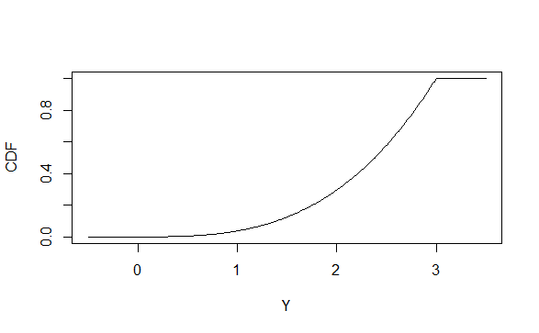

Code3:

x=seq(-1,1,0.01)

fl=(1-x^2)*(3/4)

x1=seq(-4,-1,0.01)

x2=seq(1,4,0.01)

f2=x1*0.000000

f3=0.00000*x2

plot(x1,f2,type="l",xlab="Y",ylab="PDF",xlim=c(-4,4))

par(new=TRUE)

plot(x2,f3,type="l",xlab="Y",ylab="PDF",xlim=c(-4,4))

par(new=TRUE)

plot(x,fl,type="l",xlab="Y",ylab="PDF",xlim=c(-4,4))

y=seq(-1,1,0.01)

yo=seq(-1,1,0.01)

cdf=c(rep(1,0),(y-y^3/3)*(3/4),rep(1,0))

plot(yo,cdf,type="l",xlab="Y",ylab="CDF",ylim=c(-1,1))

Output:

> x=seq(-1,1,0.01)

> fl=(1-x^2)*(3/4)

> x1=seq(-4,-1,0.01)

> x2=seq(1,4,0.01)

> f2=x1*0.000000

> f3=0.00000*x2

> plot(x1,f2,type="l",xlab="Y",ylab="PDF",xlim=c(-4,4))

> par(new=TRUE)

> plot(x2,f3,type="l",xlab="Y",ylab="PDF",xlim=c(-4,4))

> par(new=TRUE)

> plot(x,fl,type="l",xlab="Y",ylab="PDF",xlim=c(-4,4))

|  |
| --- |
| > y=seq(-1,1,0.01)  > yo=seq(-1,1,0.01)  > cdf=c(rep(1,0),(y-y^3/3)*(3/4),rep(1,0))  > plot(yo,cdf,type="l",xlab="Y",ylab="CDF",ylim=c(-1,1)) |
|  |
|  |

Graphs;

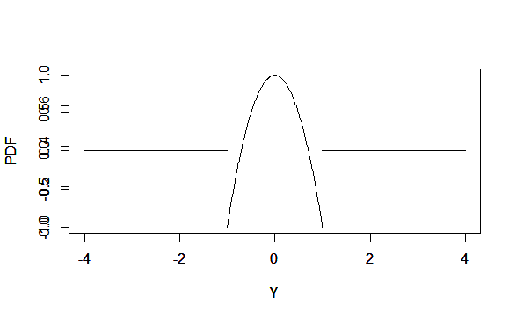

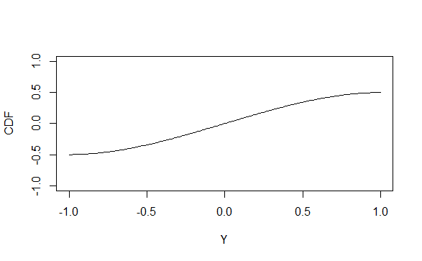

**Result:**

The PDF and CDF for a continuous Random variable were successfully plotted.